**CMS DOCUMENTATION**

**Website adminpanel login**:-

1. Type URL as: website domain name/adminpanel
2. Provide username and password

**Manage website’s Main Banner**

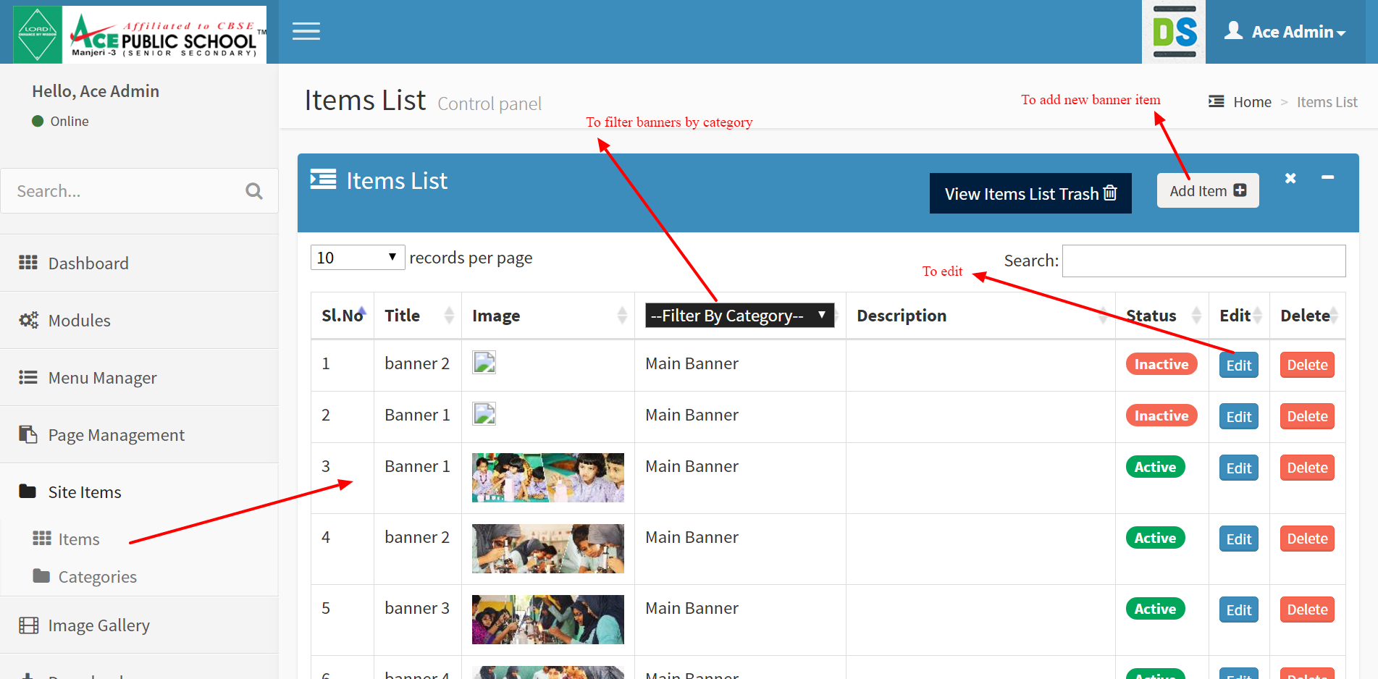

**Add a new Menu item**

Before adding a new menu item, create a Page for that menu

1. To create a Page

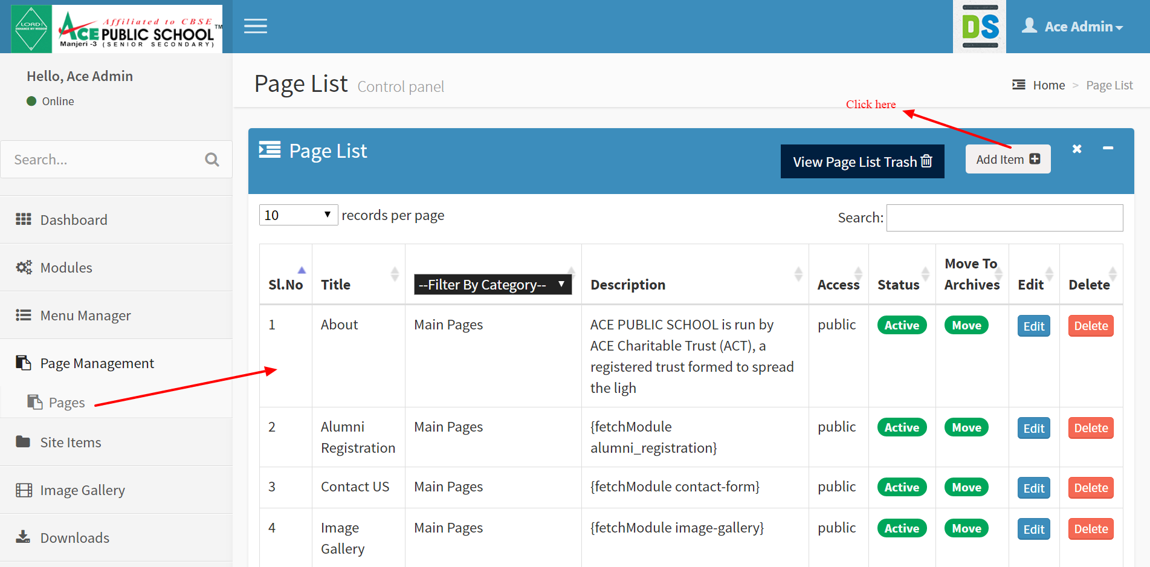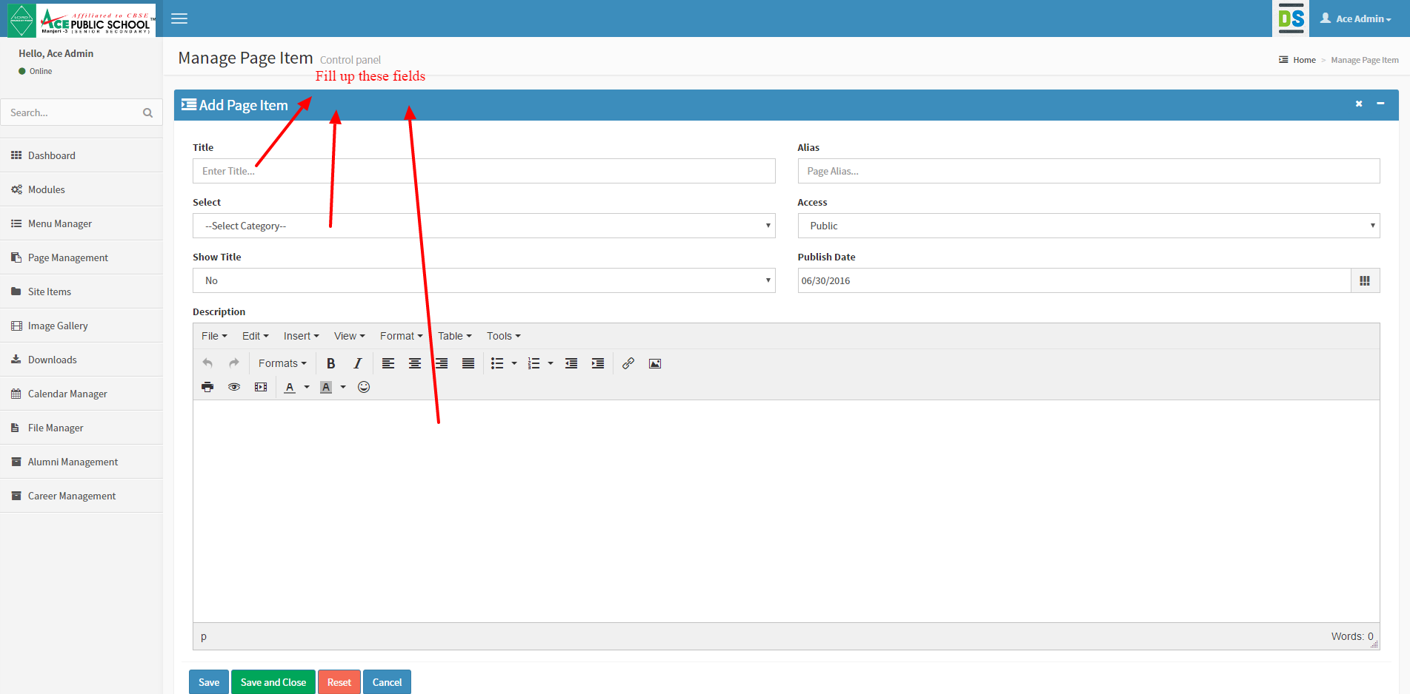

1. Then create a new Menu

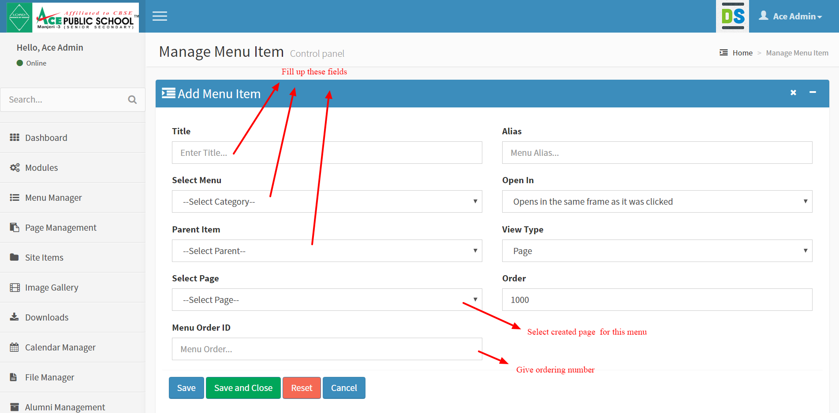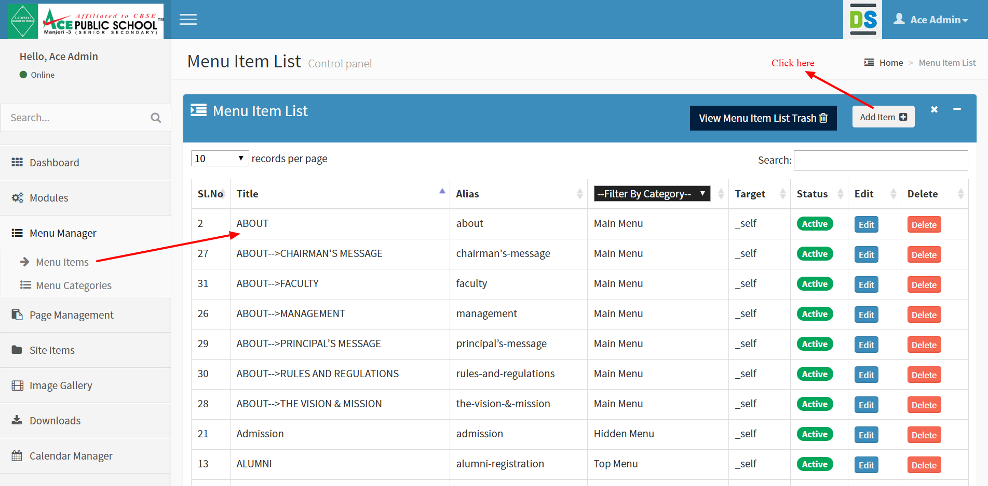

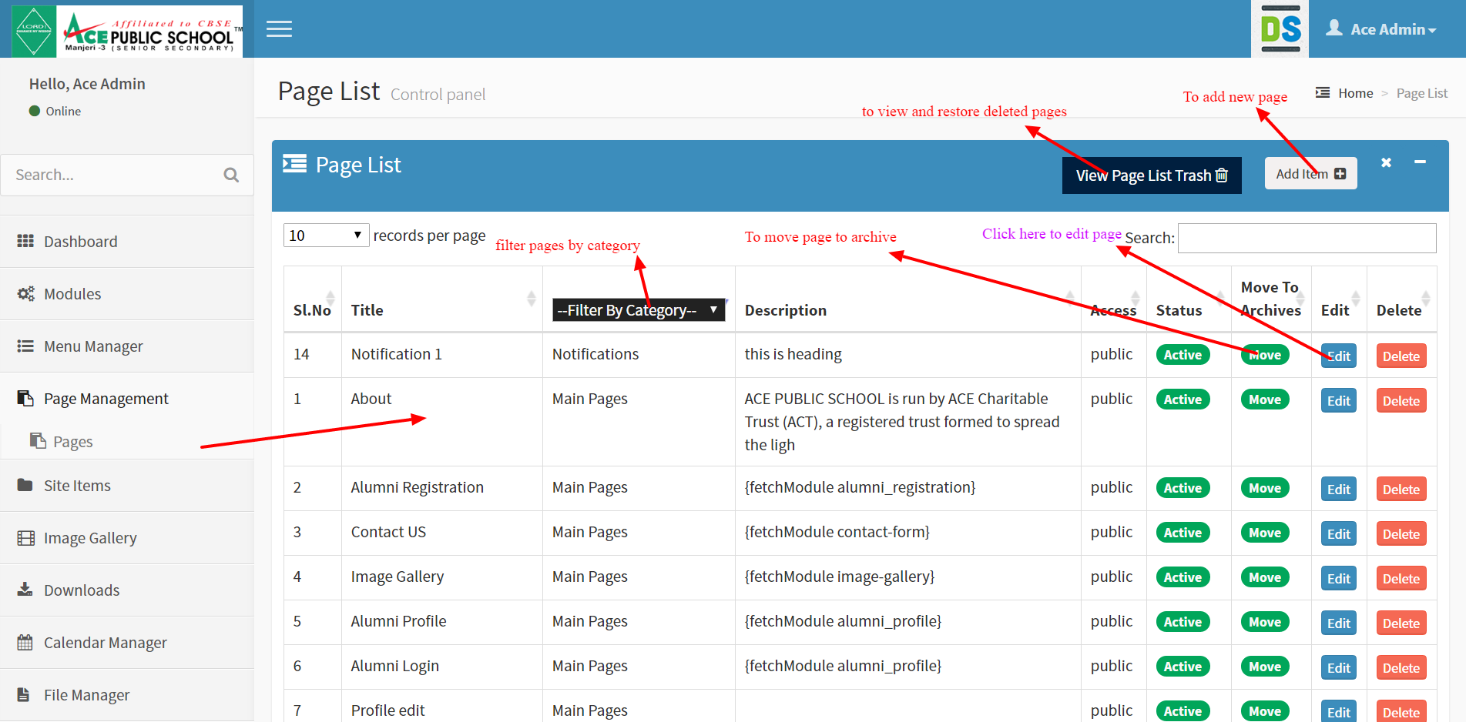**Page Management**

To edit a page: Click edit button

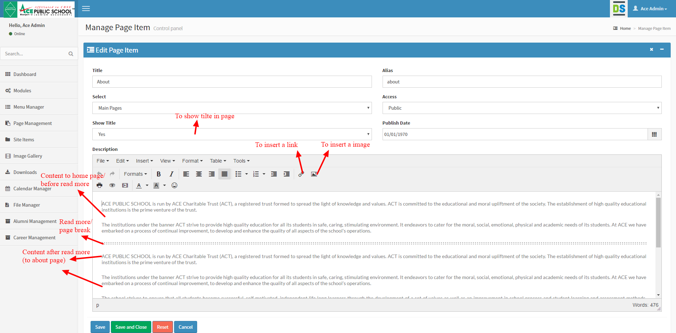

**Manage Image Gallery**

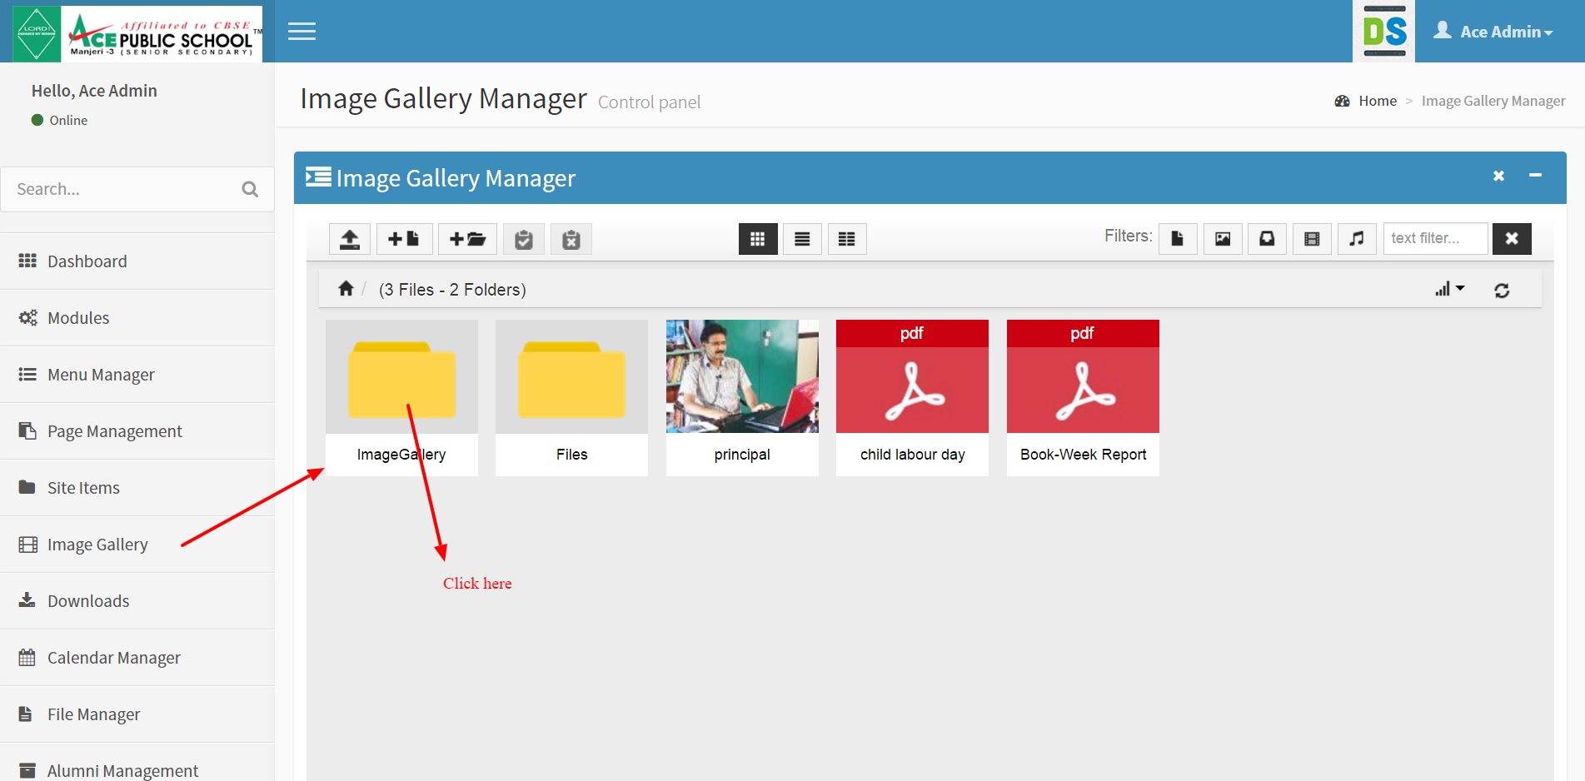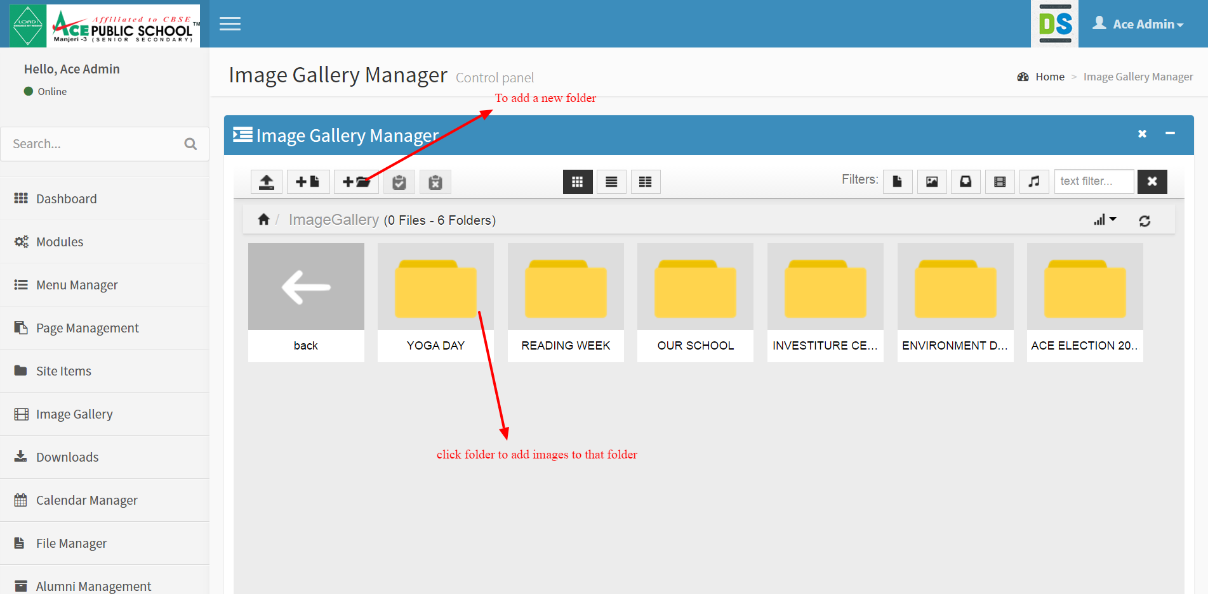

Manage News and Events

